Lab 10 – Code Review and Quality: Using AI to Improve Code

Quality and Readability
NAME: K.SAI NANDHAN
ROLL NO: 2503A52419
BATCH:14

Task Description :1 – Syntax and Logic Errors
Prompt: Use AI to identify and fix syntax and logic errors in a faulty Python script.
Input:
# Calculate average score of a student def calc_average(marks):
total = 0 for m in marks: total += m average = total / len(marks) return average
marks = [85, 90, 78, 92]
print("Average Score is", calc_average(marks)) Explanation:
The program calculates the total marks using a for loop. It divides the total marks by the number of marks to find the average. Fixed the indentation error, corrected avrage to average, and added the missing closing parenthesis.
Output:
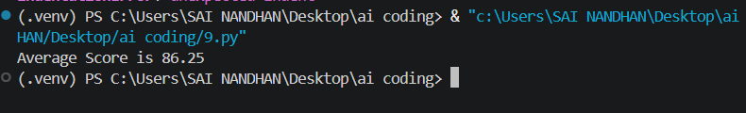
Task Description :2 – PEP 8 Compliance
Prompt: Use AI to refactor Python code to follow PEP 8 style guidelines.
Input:
def area_of_rect(length, breadth): return length * breadth
print(area_of_rect(10, 20))
Explanation:
Added proper spaces and line breaks to make the code readable and follow PEP 8 guidelines. Changed L and B to length and breadth for meaningful variable names.The function multiplies length by breadth to calculate the rectangle's area.
Output:
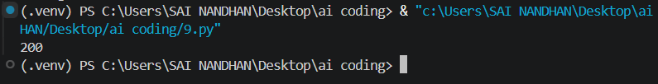
Task Description :3 – Readability Enhancement
Prompt: Use AI to make code more readable without changing its logic.
Input:
# Calculate percentage of a value def calculate_percentage(value, percentage): return value * percentage / 100
total_value = 200 percentage_value = 15
# Display the calculated result
print(calculate_percentage(total_value, percentage_value))
Explanation:
Changed variable names (c, x, y, a, b) to descriptive names for better readability.Added comments and proper indentation to make the code easy to understand.The function calculates 15% of 200 and displays the result without changing the original logic.
Output:
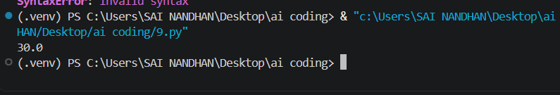
Task Description :4 – Refactoring for Maintainability Prompt: Use AI to break repetitive or long code into reusable functions.
Input:
# Function to welcome a student def welcome_student(name): print("Welcome", name)
students = ["Alice", "Bob", "Charlie"]
# Welcome all students using a loop for student in students: welcome_student(student)
Explanation:
Created a reusable function welcome_student() to display a welcome message for each student.Used a for loop to process all students instead of writing repetitive print statements.This makes the code shorter, easier to maintain, and reusable.
Output:
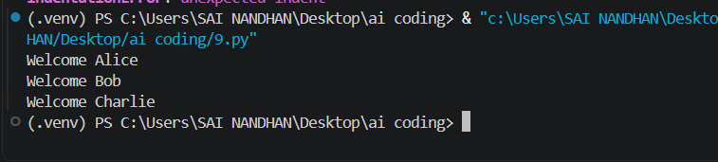
Task Description :5 – Performance Optimization Prompt: Use AI to make the code run faster.
Input:
# Find squares of numbers using list comprehension squares = [n**2 for n in range(1, 1000000)]
print(len(squares))
Explanation:
Used list comprehension to calculate squares in a single line instead of using a separate loop and append(). Removed the unnecessary nums list, reducing extra memory usage. The program calculates the squares of numbers from 1 to 999999 and prints the total count.
Output:
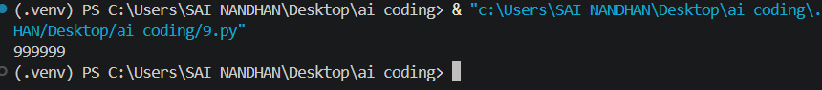
Task Description :6 – Complexity Reduction
Prompt: Use AI to simplify overly complex logic.

Input:
c
Explanation:
Replaced nested if-else statements with elif to simplify the code. The function checks the score and returns the corresponding grade. This makes the code cleaner, easier to read, and easier to maintain.
Output:

